Final Year Design Project Software Design Specification

CryptoSence

Final Year Design Project SDS

Project ID:22-KS-BSIT-16

By

Hamza Nadeem 089305(2022-KS-171)

Syed Mohsin Abbas 089330(2022-KS-178)

(Evening)

Project Advisor:

Muhammad Kamran

Govt. Graduate College, Civil Lines, Sheikhupura

University of the Punjab Lahore, Pakistan

(2025)
CryptoSence

Executive Summary
CryptoSence is a web-based cryptocurrency dashboard enhanced with a secure login system and an AI chatbot. It allows users to view real-time crypto prices, analyze charts, and interact with an intelligent assistant for insights, definitions, and recommendations. The system integrates CoinGecko API for live market data and OpenAI API for AI chatbot responses. A Node.js and Express are backend manages authentication, while MongoDB stores user data securely.

Contents
Executive Summary 2
System Design 5
Product Perspective: 5
Dependencies: 5
Design Constraints: 5
Design Considerations 6
Assumptions 6
Dependencies 6
Limitations 6
Risks 7
Requirements Traceability Matrix 7
Design Models 8
Architectural Design 8
• Class Diagram 9
• Component Diagram 10
Data Design 10
Database Collections Structure: 10
Data Dictionary 11
User Interface Design 11
Screen Images 14
Behavioural Model 19
Sequence Diagram 19
State Diagram 21
Design Decisions 22
Summary 23
References 23

List of Table
Table 1 Requirements Traceability Matrix 8
Table 2 Data Dictionary of User Collection 11
List of Figure
Figure 1 Architectural Diagram 9
Figure 2 Class Diagram 9
Figure 3 Component Diagram 10
Figure 4 Home Page Design 14
Figure 5 Login Page Design 15
Figure 6 Dashboard Page Design 16
Figure 7 CryptoBot Page Design 17
Figure 8 User Registration Sequence Diagram 19
Figure 9 Dashboard Sequence Diagram 20
Figure 10 User Registration State Diagram 21
Figure 11 Dashboard State Diagram 22

System Design

Product Perspective:
The website name is cryptosence and it is a client–server architecture.
The cryptosence website provide:
- Live crypto data
- AI bot for prediction and explanation
- User login/signup
- Crypto education support
It is made using the MERN stack

Dependencies:
CryptoSence needs the following things to work:
- Coingecko API to get live crypto market data.
- OpenAI API to generate prediction.
- React.js to make the website
- Chart.js to show crypto charts
- Node.js + Express for backend
- MongoDB to store user accounts
- Internet connection must required

Design Constraints:
- Performance Requirements: The live crypto data showing and AI bot response in a few seconds and work fast
- Usability Requirements: The website is friendly, easy to use and also work on mobile and computer
- Security Requirements: User password and login must be safe/secure. And api keys should be hidden

Design Considerations
Limitations: The live crypto data show by API call from coingecko because of free version The ai bot is depend on volume, RSI and support/resistance and both are depend on internet.
Risks: If API of coingecko and openAI is fail due to some reason the live crypto data or ai bot response is also not work secondly if the more users call api from coingecko so we need to buy paid version.

Assumptions
Following are the assumptions:
- The system needs a stable internet connection
- User have a phone or computer with a web browser.

Dependencies
Following are the dependencies:
- Coingecko API for live crypto market data.
- OpenAI API for generate answers.
- Internet connection.
- React.JS, Node.JS, Express.JS and MongoDB.

Limitations
Following are the limitations:
- Live crypto data uses free coingecko API which have limited request.
- AI bot depend upon volume, RSI, and support/resistance for prediction.
- Both are not work without internet
- Free API may be slow or stop if to many people use it.

Risks
Following are the risks:
- If API of coingecko and openAI is fail due to some reason the live crypto data or ai bot response is also not work.
- Secondly if the more users call api from coingecko so we need to buy paid version.

Requirements Traceability Matrix
Requirement ID | Requirement Description | Design Specification
FR-1 | The user shall be able to register by entering username, email and password then account create | Component “use authentication”
FR-2 | The user should be login by entering email and password then view the dashboard | Component “use authentication”
FR-3 | The user shall be able to reset their password by email A reset link will be sent to the provided email and allowing the user to create a new password | Component “use authentication”
FR-4 | The user should be sign in/up by google account | Component “use authentication”
FR-5 | The user can access real time price, percentage coin and market data, search bar for searching any currencies and also view crypto currencies charts and other update which you went to know. | Component “coin data service”
FR-6 | The user can know about any cryptocurrencies prediction, trends and also few line of explanation about cions | Component “chatbot”
FR-7 | The user can also access the best education platform, books and YouTube channel links which will be arranged in sequence of learning | Component “learning Page for education service”
FR-8 | The user went to logout from dashboard securely | Component “use authentication”
Table 1 Requirements Traceability Matrix

Design Models
The cryptosence is a three-tier architecture:
- Presentation Layer (React.js, HTML, CSS)
- Application Layer (Node.js/Express.js)
- Data Layer (MongoDB)
This is object oriented programming approach.

Architectural Design
The system uses a multi-tier design which means the work is divided into different parts. Each part has its own job. This makes the system easier to manage, faster to update, and better at handling changes.

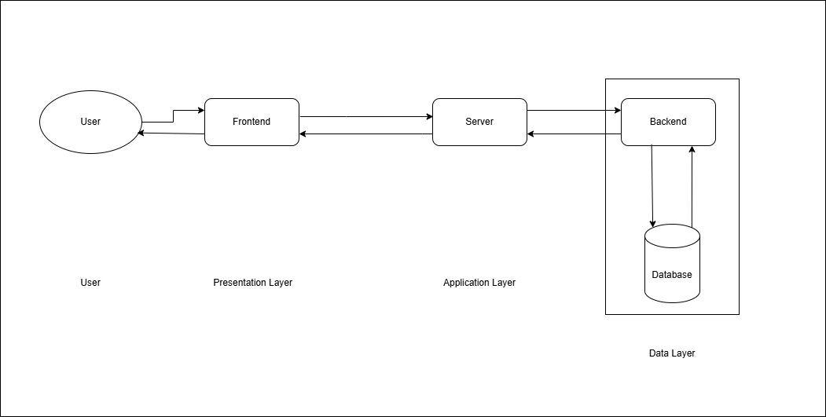
Figure 1 Architectural Diagram

Class Diagram

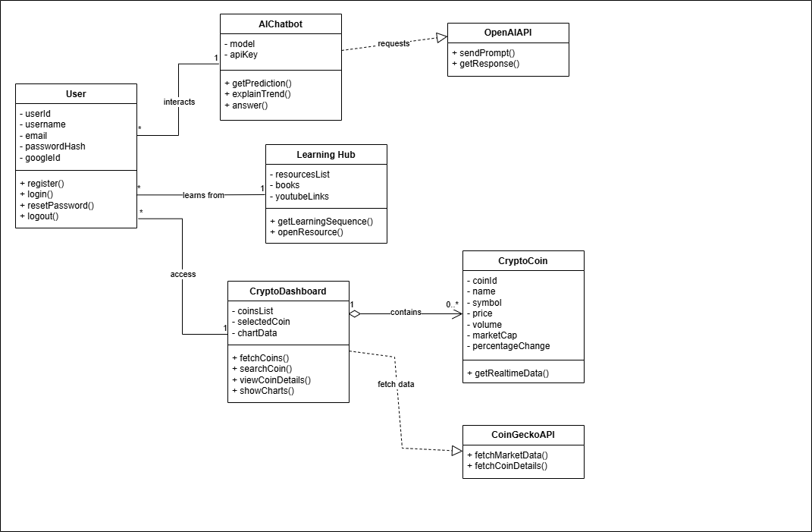
Figure 2 Class Diagram

Component Diagram

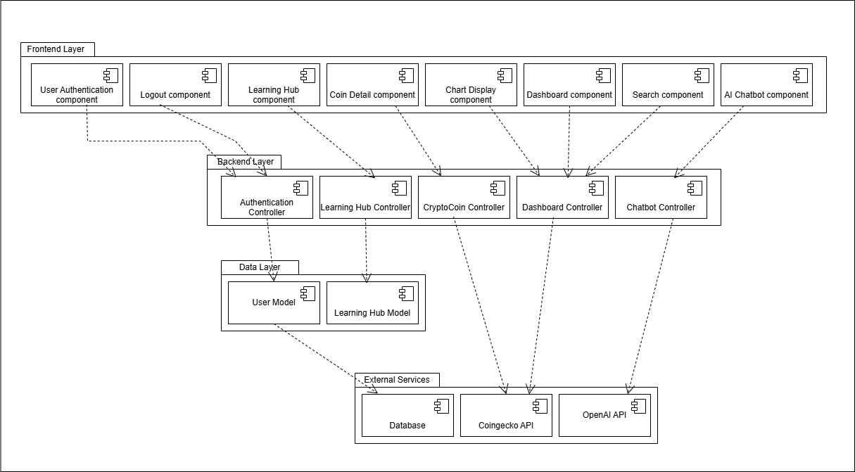
Figure 3 Component Diagram

Data Design
The CryptoSence system converts real-world user actions into structured data stored in MongoDB. Because crypto prices and charts come directly from CoinGecko API, they are NOT stored in the database. Only user-related data are stored.
Each main entity from the system is represented as a MongoDB collection with specific fields for efficient data management.

Database Collections Structure:
Users Collection
- Stores all user accounts.
- Includes normal login and Google login support.
- Used for authentication and personalization.
Fields:
- userId: Unique identifier
- username: Full name of the user
- email: User email (unique)
- passwordHash: Encrypted password (null if Google login)
- googleId: Google account ID (optional)
- createdAt: Account creation date
- lastLogin: Last login timestamp
Data Relationships:
- One-to-one: Each user has one account.
- No crypto data stored: All coin details come from CoinGecko API.

Data Dictionary
Users Collection:
Terminology | Description
userId | String, Primary key for user
username | String, User full name
email | String, Unique email address
passwordHash | String, Encrypted password
googleId | String, Google login ID (optional)
createdAt | Date, When user registered
lastLogin | Date, Last time user logged in
Table 2 Data Dictionary of User Collection

User Interface Design
The user interface of cryptosence shows clean and simple data which can easily understand for user. The design helps users quickly find crypto data, use the AI bot and eduction support.

User Experience

- The system is easy to use and works smoothly on both mobile and computer.
- Users can access live crypto data, charts, and AI bot answers in just a few clicks.
- Information is shown in a clean and simple format so users understand it quickly.
- The system loads fast and gives clear messages if something goes wrong.
- The whole experience is friendly, comfortable, and designed to help beginners and experts both

How the User Uses the System

1. Open the Website
- User opens the CryptoSence website on mobile or computer.
2. Login or Signup
- If the user is new they create an account.
- If the user already has an account they login with email/password or google.
3. Go to Dashboard
- After login, the user enters the dashboard automatically.
- They can see:
  - live crypto prices
  - percentage change
  - charts
  - search bar
4. Search & View Crypto Details
- The user types a coin name Bitcoin.
- The system shows price, chart, and market details.
5. Use the AI CryptoBot
- The user goes to the AI Bot page.
- They ask questions like:
  - Give prediction
  - Explain trends
- The bot replies with simple explanations.
6. Visit the Learning Page
- Users can read educational content and open links to books, videos, and tutorials.
7. Logout
- When the user finishes, they logout safely from the dashboard

Screen Images

Home Page
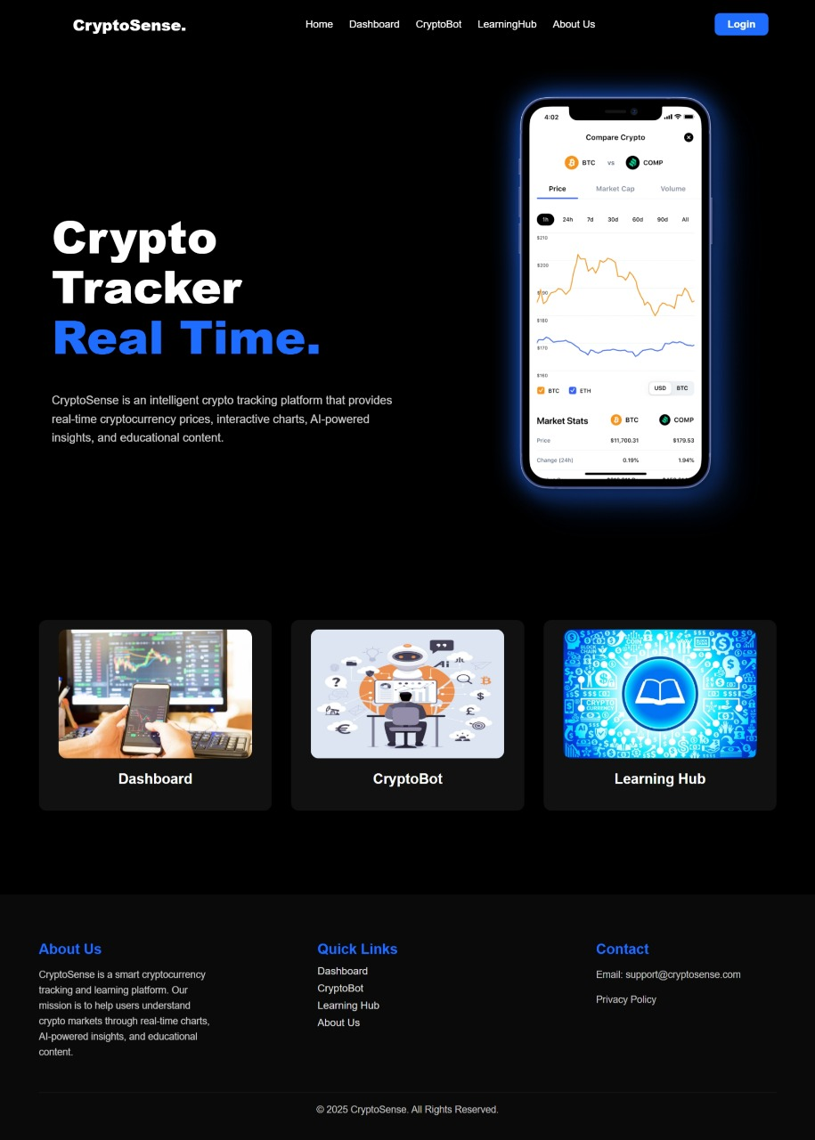
Figure 4 Home Page Design

Login Page
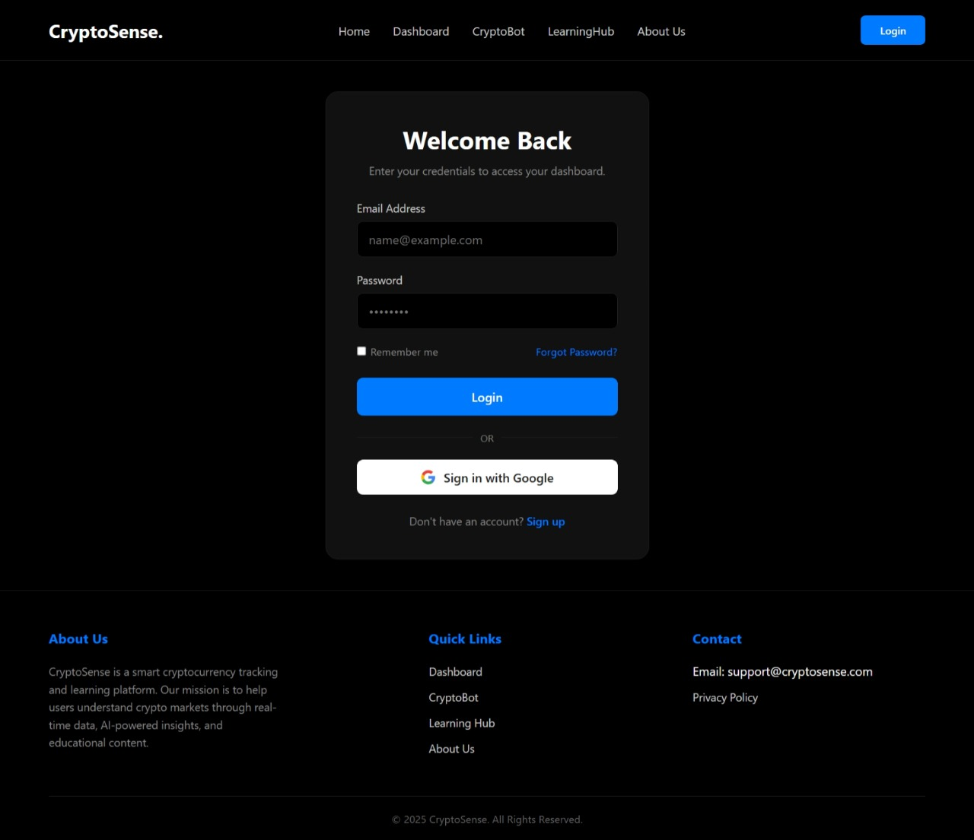
Figure 5 Login Page Design

Dashboard Page
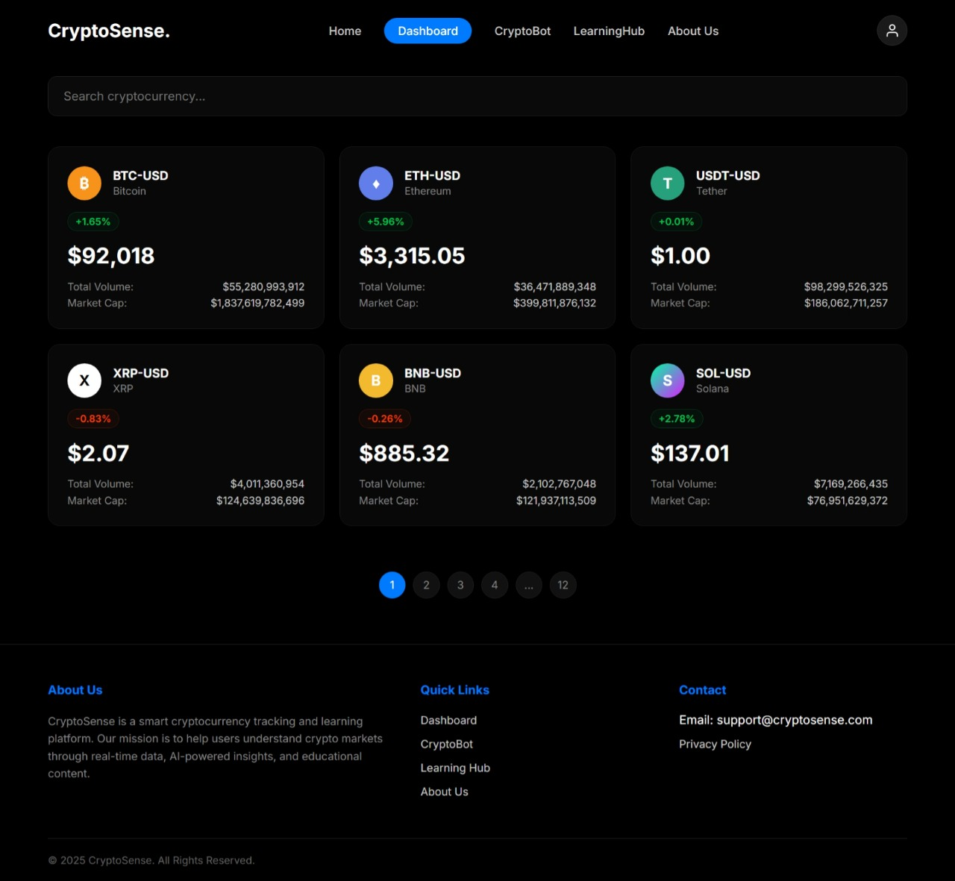
Figure 6 Dashboard Page Design

CryptoBot Page
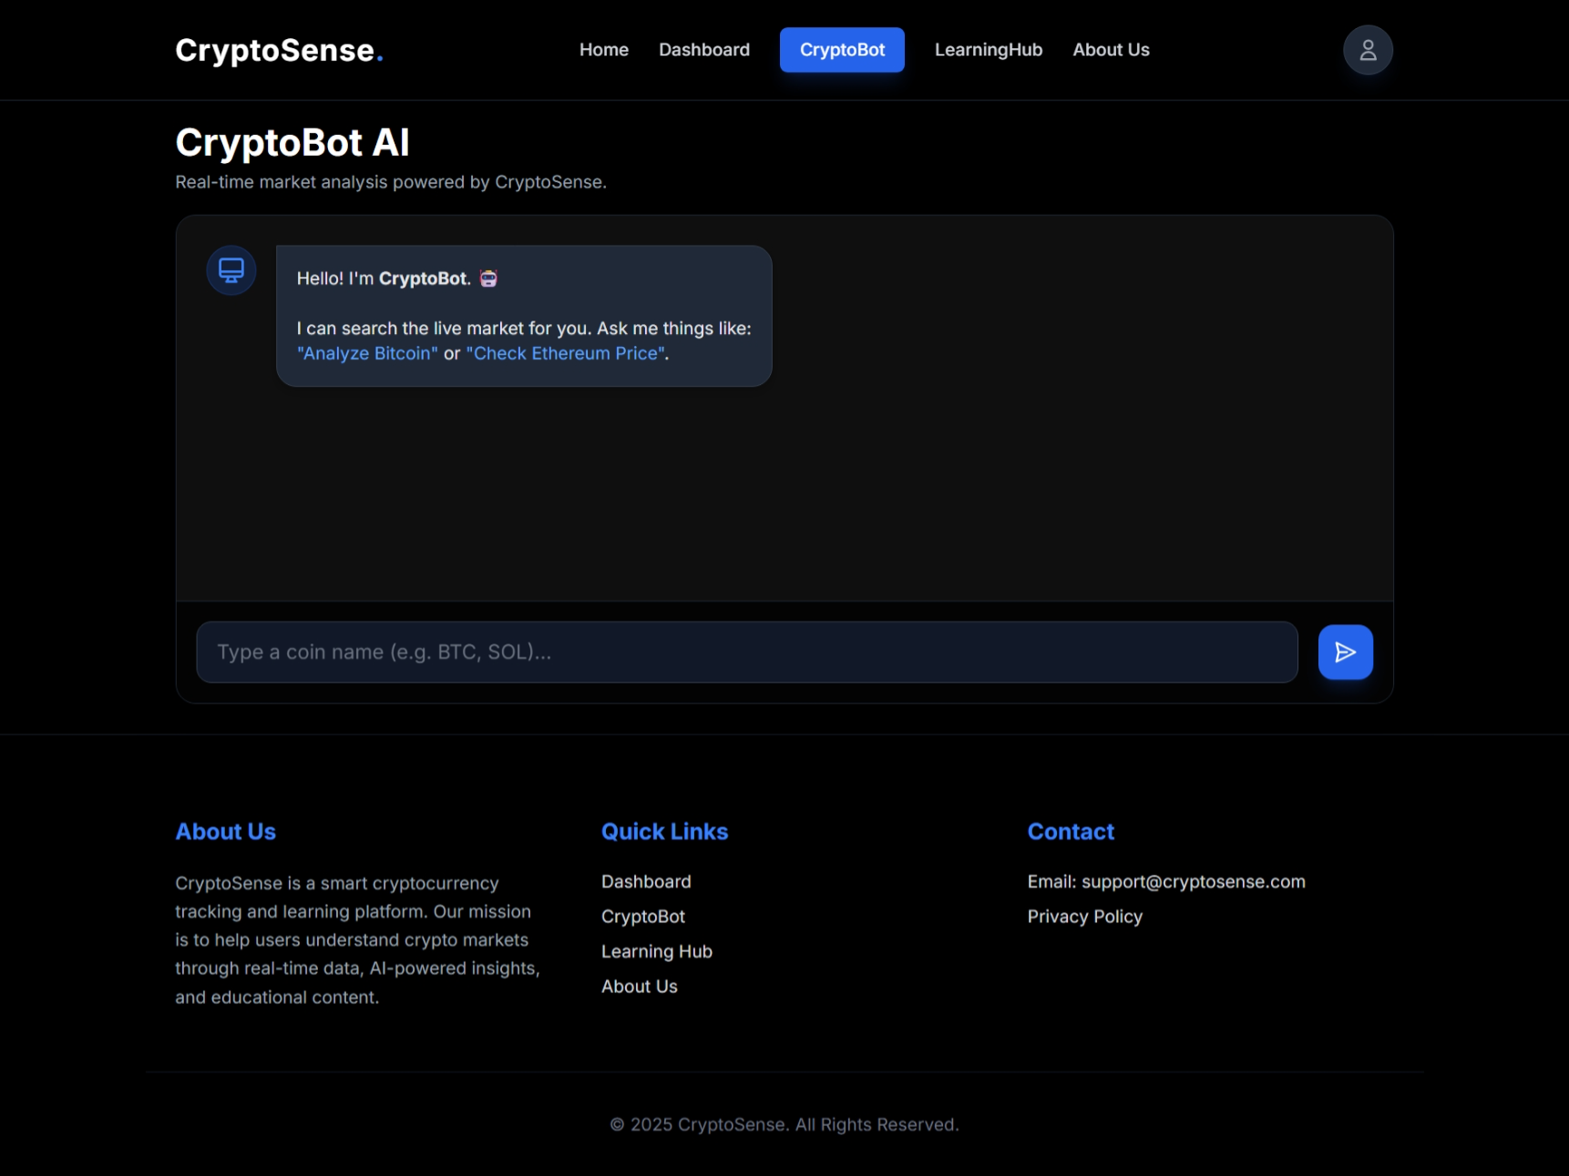
Figure 7 CryptoBot Page Design

Screen objects and action

Screen Objects
- Nav bar: Home, Dashboard, AI bot, Learning, Logout.
- Buttons: Login, Sign in, Google sign in/up, Search, Chat send
- Input Fields: Email, Password, Username, Search bar, Chat
- Boxes: Crypto price, chart, info.
- Charts: Chart for price
- Lists: Crypto list with price and percentage change.
- Icons: Search, profile, menu.
- Messages: AI bot messages.
- Footer: Links or credits.

User Actions
- Login / Sign in: User enters details and click login or sign in.
- Search Crypto: User search coins from bar.
- View Details: User clicks on a coin to see price, chart, and market data.
- AI Bot: User use it for prediction and explanation about any coin.
- Nav Page: User clicks Dashboard, CryptoBot, Learning, etc.
- Logout: User clicks the logout to exit
- Google sign in/up: User signs in/up with google account.

Behavioural Model

Sequence Diagram
- User Registration Sequence Diagram
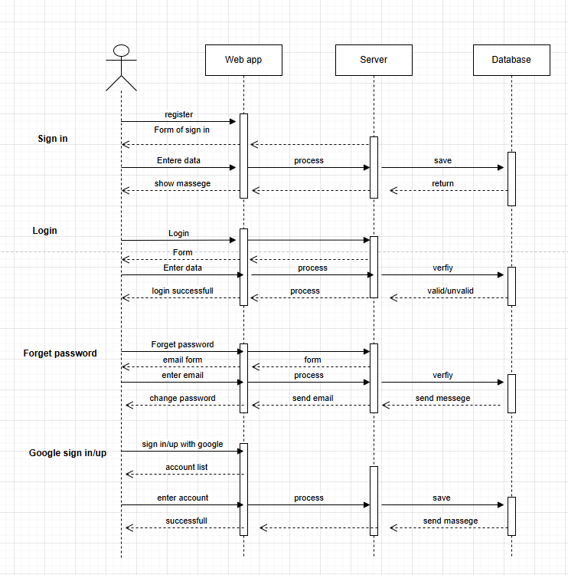
Figure 8 User Registration Sequence Diagram
- Dashboard Sequence Diagram

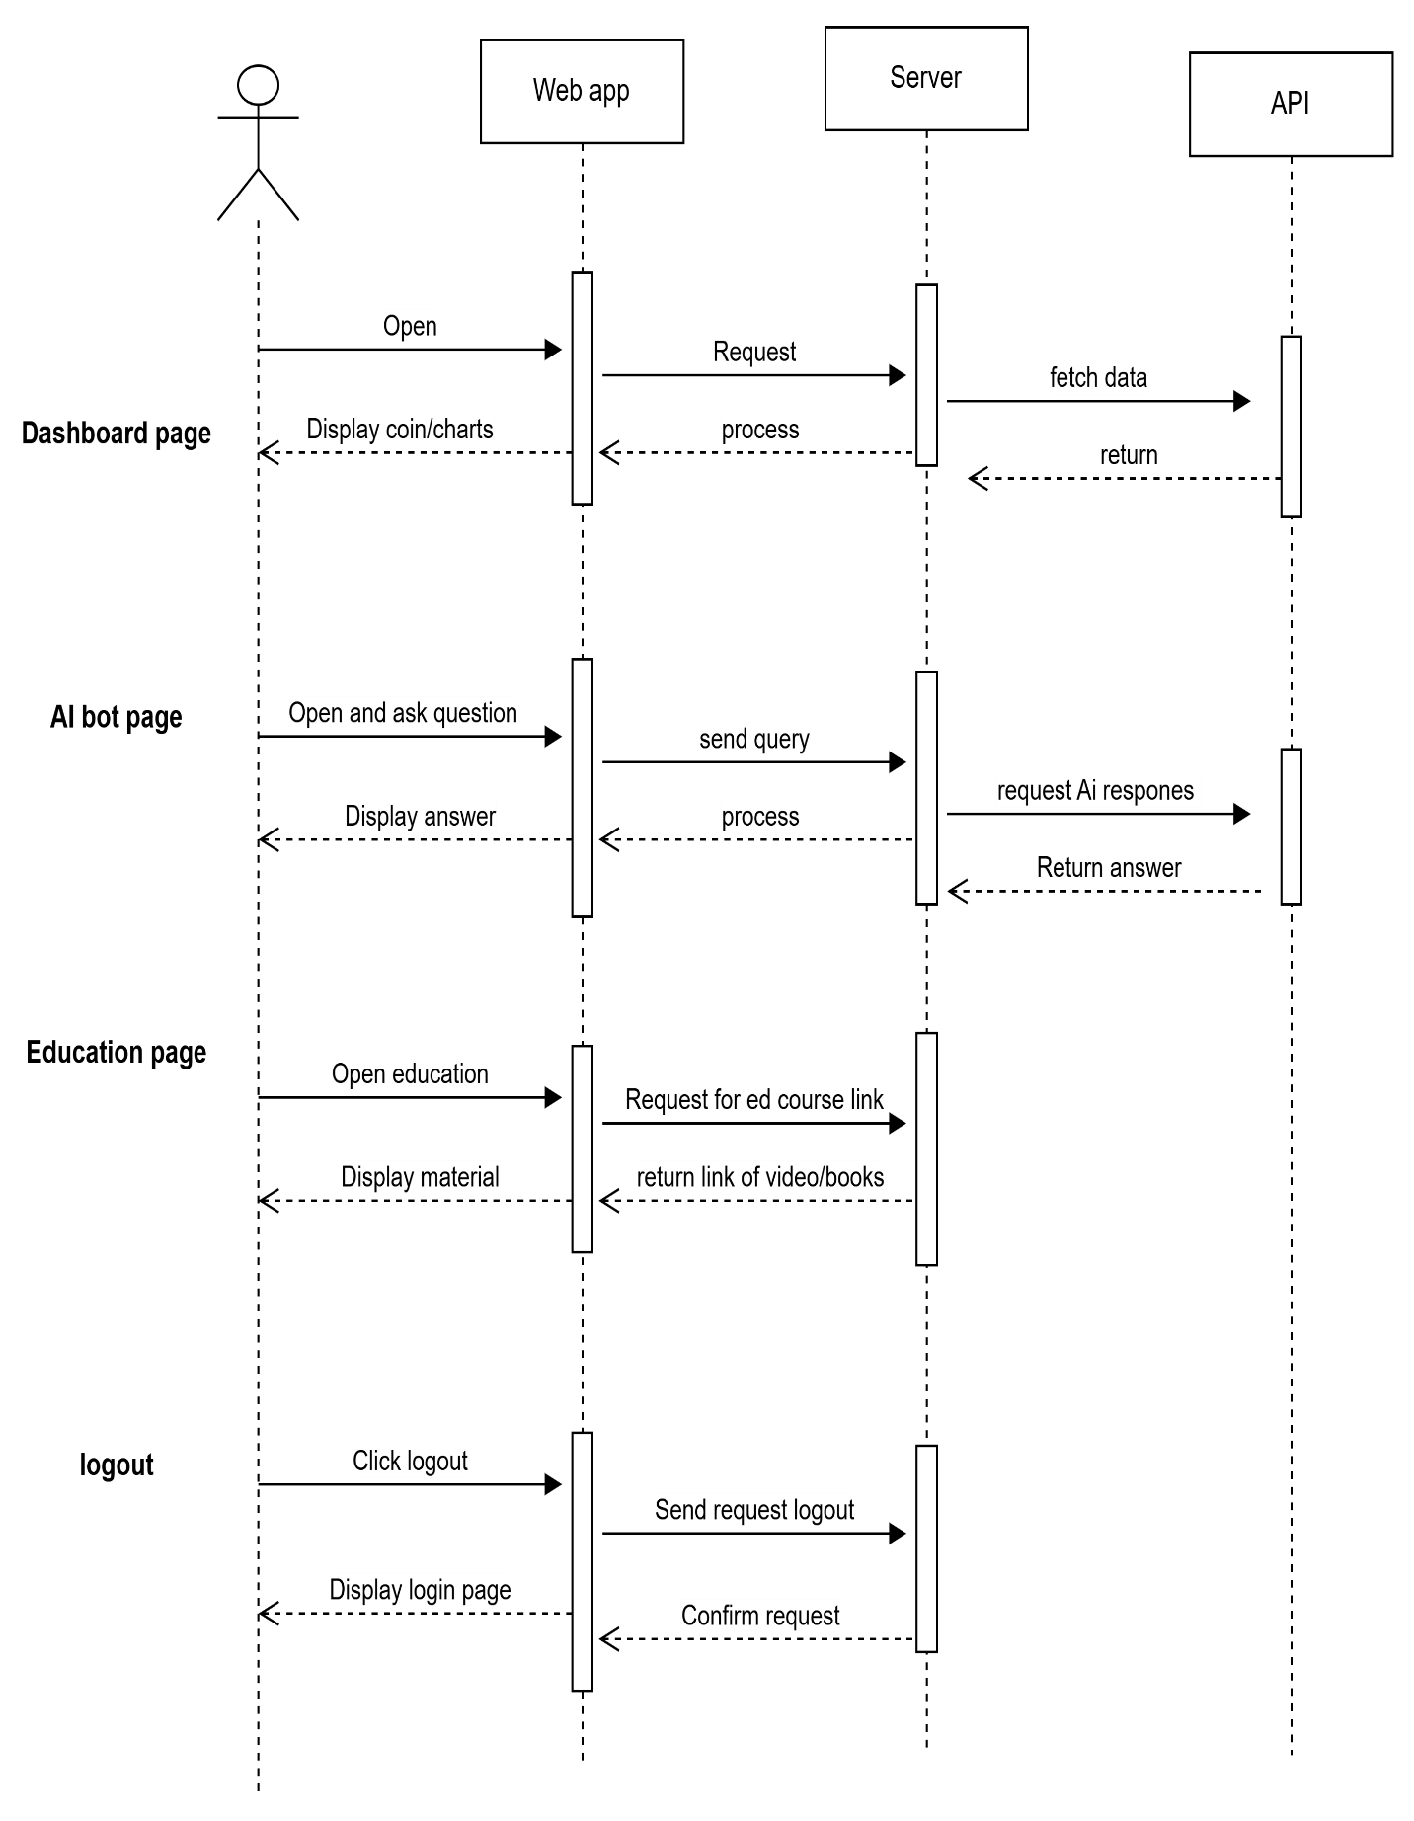
Figure 9 Dashboard Sequence Diagram

State Diagram
- User Registration State Diagram
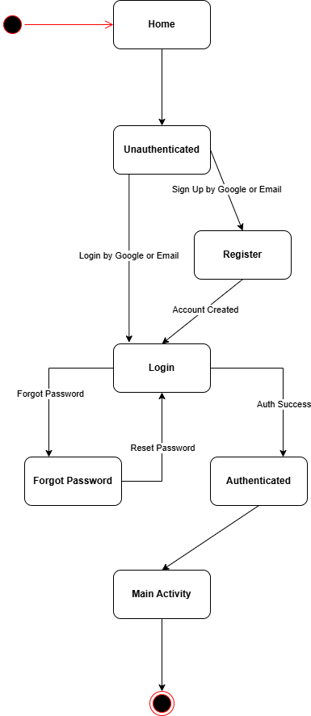
Figure 10 User Registration State Diagram
- Dashboard State Diagram
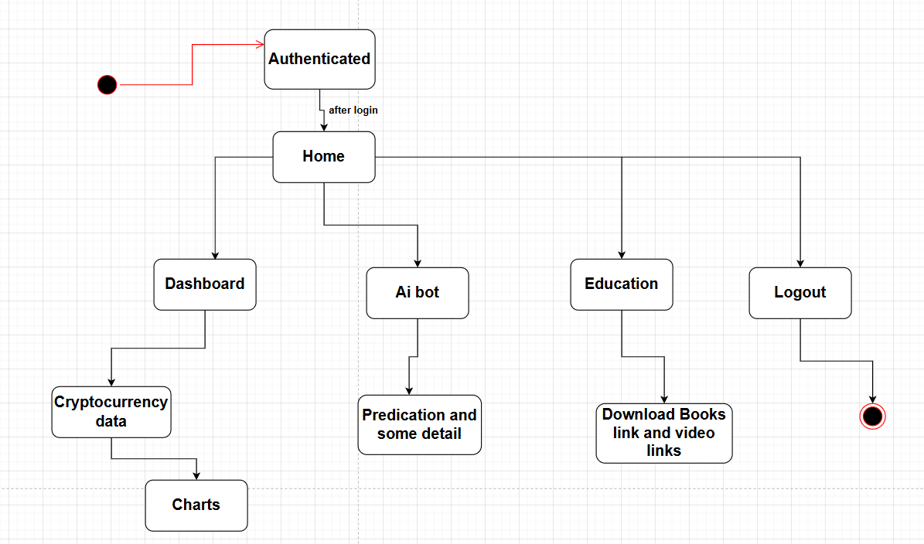
Figure 11 Dashboard State Diagram

Design Decisions
The system made several key architectural and technological choices to ensure the platform is secure, scalable, maintainable and a high quality user experience.
- Object Oriented Design (OOD):
We used the object oriented approach to build our system around real world entities such as User, Session, Chatmessage, and APIrequest. This code reusability and makes the system easier to use, test, and maintain in the future.
- MVC (Model-View-Controller) Architecture:
The system follows the Model-View-Controller pattern to separate concerns clearly:
  - Model interacts with MongoDB.
  - View is managed by React.js components
  - Controller contains the Express.js routes.
- Database Design with Mongodb:
We selected Mongodb for its flexibility in handling unstructured and semi structured data which aligns well with the dynamic nature of user profiles and session data. While relational normalization was considered Mongodb document model allows for efficient storage and retrieval of user-centric data without requiring complex joins.
- Rules & AI bot Logic:
  - A rule-based layer handle queries to show cryptocurrency data.
  - An AI layer using OpenAI API provide prediction and trend explanation which based on technical indicators like volume, RSI, and support/resistance level.
- Technology Stack Selection:
  - Frontend: React.js with Chart.js.
  - Backend: Node.js and Express.js.
  - Database: MongoDB
  - Authentication: JWT (JSON Web Tokens) with bcrypt password hashing ensures secure user session and data protection.
External APIs: Coingecko API for real time cryptocurrency data and OpenAI API for intelligent responses

Summary
This software design specification outlines the architectural, data, and behavioral designs for cryptosence. The system show live crypto data, AI bot, and educational content into one secure, fast, and user friendly platform.

References
Books
- Vaida, Bogdan. Zero to Hero in Cryptocurrency Trading: Learn to trade on a centralized exchange, understand trading psychology, and implement a trading algorithm. Birmingham, UK: Packt Publishing, 2023.
- Batish, Rachel. Voicebot and Chatbot Design: Build Conversational Experiences. London: Paradigm Publishing, 2018.
- Lewis, Antony. The Basics of Bitcoins and Blockchains: An Introduction to Cryptocurrencies and the Technology that Powers Them. London: Kogan Page, 2018.

Journal Articles
- Kumar, A. and Singh, R. “Web-Based Cryptocurrency Systems: A Review.” International Journal of Computer Applications, vol. 97, pp. 12–19, Mar. 2019.
- Chaves, Ana Paula; Egbert, Jesse; Hocking, Toby; Doerry, Eck; Gerosa, Marco Aurélio. “Chatbots Language Design: The Influence of Language Variation on User Experience.” arXiv preprint arXiv:2101.11089, Jan. 2021.
Conference Proceedings
- Javed, M. and Ali, H. “Designing Secure Web Portals for Crypto Services.” In Proc. International Conference on Information Systems, 2020, pp. 221–230.
- Rahman, T. “User-Friendly Interfaces for AI Chatbots.” In Proc. Global IT Summit, 2021, pp. 112–118.
World Wide Web
- CoinGecko. “CoinGecko API Documentation.” Internet: https://www.coingecko.com/en/api, n.d. [Accessed: Nov. 11, 2025].
- OpenAI. “OpenAI API Documentation.” Internet: https://platform.openai.com/docs, n.d. [Accessed: Nov. 11, 2025].
- MongoDB. “MongoDB Atlas Documentation.” Internet: https://www.mongodb.com/atlas, n.d. [Accessed: Nov. 11, 2025].
- Express.js Team. “Express.js Documentation.” Internet: https://expressjs.com/, n.d. [Accessed: Nov. 11, 2025].
- React Team. “React.js Official Documentation.” Internet: https://react.dev/, n.d. [Accessed: Nov. 11, 2025].

